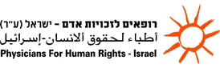
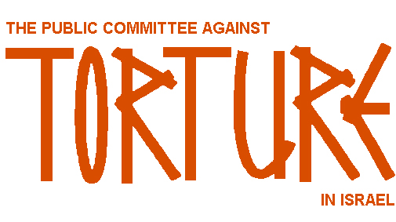


Al-Haq



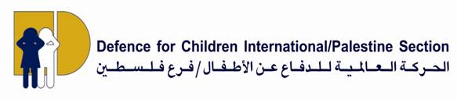

Al Mezan
Center for Human Rights

30 April 2009

UN Committee Against Torture to Review Israel on 5-6 May 2009

Palestinian and Israeli Human Rights NGOs to Brief UN on Israel’s Systematic and Institutionalised Practices of Torture and Ill-Treatment
including Acts Committed during the Recent Military Offensive on Gaza

On 5 and 6 May 2009, the UN Committee against Torture (the Committee) will review Israel's compliance with the Convention against Torture and Other Cruel, Inhuman or Degrading Treatment or Punishment (CAT). At this session, Israel will respond to a "List of Issues" posed by the Committee in December 2008. Israel last appeared before the Committee in 2001.

Immediately prior to the hearings, on 4 May 2009, Adalah, Al-Haq, Defence for Children International – Palestine Section (DCI-PS), Physicians for Human Rights – Israel (PHR – Israel) and the Public Committee Against Torture in Israel (PCATI), will orally brief the Committee at an NGO session on Israel's systematic and institutionalised practices of torture and ill-treatment and other violations of CAT committed during Israel's military operation "Cast Lead", which took place in Gaza from 27 December 2008 – 18 January 2009. The NGOs will base their briefing on three reports and 154 pages of evidence submitted to the Committee by member and partner organisations of the United Against Torture Coalition (UAT Coalition). The Gaza-based Al Mezan Center for Human Rights was not able to take part in the briefing due to the closure of the Gaza Strip.
The delegation will convey five key points to the Committee:

- Israel's practices of torture and ill-treatment against Palestinians have continued unabated since the Committee last reviewed Israel in November 2001;
- Evidence of acts, omissions and complicity by agents of the State of Israel at all levels, including the army, the intelligence service, the police, the judiciary and other branches of government have been observed and recorded;
- The use of torture and ill-treatment by Israeli authorities against Palestinians is both widespread and systematic;
- The State of Israel is either unwilling or unable to fulfil its obligations under the Convention; and
- Until the culture of impunity is addressed, the situation is unlikely to improve, and the Committee will find itself issuing similar concluding observations and recommendations in four years time during its next review of Israel.

For the UAT Coalition’s full reports and evidence annexes to the Committee in English, see the following:

- Supplementary Report to CAT, April 2009
- Israeli "Operation Cast Lead" - Gaza Strip: Supplementary Report to CAT, April 2009
- Annexure A, Supplementary List of Evidence, Supplementary Report to CAT, April 2009
- UAT Coalition, 3rd Annual Report on Torture and Ill-Treatment in Israel and the OPT, submitted to CAT in 2008

For separate reports submitted to the Committee by PCATI, Amnesty International, COHRE and B’Tselem and Hamoked; Israel's report to CAT; and the "List of Issues", please see the Committee’s webpage: http://www2.ohchr.org/english/bodies/cat/cats42.htm

- Ends -

Adalah – The Legal Center for Arab Minority Rights in Israel; Al-Haq – Law in the Service of Man; Al-Mezan Center for Human Rights; Al-Quds University Human Rights Clinic; An Najah University Centre for Democracy and Human Rights; Defence for Children International – Palestine Section (DCI/PS); Gaza Community Mental Health Program (GCMHP); Hurriyat – Centre for Defence of Liberties and Civil Rights; Italian Consortium of Solidarity (ICS); Nadi Al-Asir (Palestinian Prisoners Club); Nafha Society for Defence of Prisoners and Human Rights; Mandela Institute for Human Rights and Political Prisoners; Public Committee Against Torture in Israel (PCATI); and Treatment and Rehabilitation Centre for Victims of Torture (TRC). Additional contributors to the reports to the UN Committee Against Torture included Addameer - Prisoners Support and Human Rights Association and Physicians for Human Rights - Israel.

