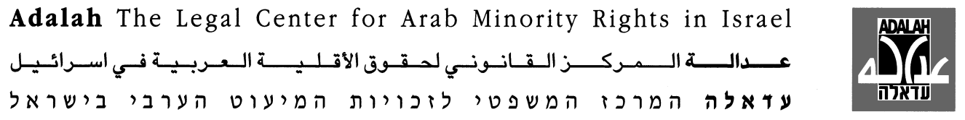

Adalah’s Training Course for Lawyers on
Representing Detainees in Detention and Investigation Procedures

Al-Tantour Center, 1 Rosemarine St., Jerusalem
17-18 March & 7-8 April 2011

* Welcoming remarks to be given by a representative of the European Union

Session | Lecturer | Subject | Time
Session 1  Thursday  17 March 2001 | Attorney Orna Kohn  Adalah | Welcome and introduction | 17:00 – 17:30
Session 1  Thursday  17 March 2001 | Prof. Kenneth Mann  Libai-Mann Law Office, former Israeli Public Defender | The role of the criminal defense lawyer | 17:30 – 19:00
Session 1  Thursday  17 March 2001 | Dr. Khaled Ghanayem  Senior lecturer, Faculty of Law, University of Haifa | The use of lethal force during arrest | 19:15 – 20:30
Session 2  Friday  18 March 2011 | Attorney Orna Kohn  Adalah | Police violence against detainees | 09:30 – 11:30
Session 2  Friday  18 March 2011 | Attorney Arwa Hleihel  Adalah | The representation of juveniles in criminal proceedings in the Israeli courts | 11:45 – 13:15
Session 2  Friday  18 March 2011 | Attorney Eyad Misk  Lawyer, Defense for Children International-Palestine | The representation of juveniles in the Israeli military legal system (lecture in Arabic) | 14:15 – 15:45
Session 2  Friday  18 March 2011 | Attorney Lea Tsemel  Human rights lawyer | The detention of suspects for security offenses | 16:00 – 17:30
Session 3  Thursday  7 April 2011 | Attorney Bana Shoughry-Badarne  Legal Director, Public Committee Against Torture in Israel (PCATI) | Torture and illegal interrogation methods | 17:00 – 18:30
Session 3  Thursday  7 April 2011 | Attorney Hussein Abu Hussein  Lawyer specializing in criminal law, representing security detainees and torts | Denial of access to legal counsel for security detainees and detention until the end of legal proceedings | 18:45 – 20:15
Session 4  Friday  8 April 2011 | Ms. Anat Litvin and Dr. Zeev Wiener  Physicians for Human Rights-Israel | Medical aspects of torture | 09:30 – 11:00
Session 4  Friday  8 April 2011 | Attorney Gabi Lasky  Gabi Lasky & Partners | The legal representation of protesters in civilian and military courts | 11:30 – 13:30
Session 4  Friday  8 April 2011 | Attorney Abeer Baker  Director of the Prisoners’ Rights Legal Clinic, University of Haifa | The rights of prisoners classified as security prisoners | 13:30 – 15:00
Session 4  Friday  8 April 2011 | Attorney Orna Kohn  Adalah | Closing remarks and presentation of certificates | 15:30 – 16:30

 This Project is funded by the European Union
Joint project of Adalah, Al Mezan (Gaza) and Physicians for Human Rights-Israel

