Adalah is Pleased to Announce the Publication of our Land Planning and Justice Journal:

Makan
Volume 2 – The Right to a Spatial Narrative

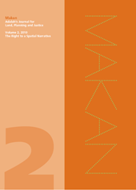
- Introduction, The Editors
- Zionizing the Palestinian Space: Historical and Historiographical Perspectives, Ilan Pappe
- The Islamic Waqf in Yaffa and the Urban Space: From the Ottoman State to the State of Israel, Mahmoud Yazbak
- "The Jaffa Slope Project": An Analysis of "Jaffaesque" Narratives in the New Millennium, Ravit Goldhaber
- “Reprogramming" through Forced "Modernization", The Editors
- Excerpts from Adalah's objection to "Partial Regional Master Plan", For the Be'er Sheva Mtropolitan Area, Master Plan 14/4, Amendment 23
- Excerpts from the oral response of the planning authorities to Adalah's objection to "Partial Regional master Plan", Delivered at a hearing held on 2 July 2008
-----------------------------------------------------------------------------------------------------------------

Makan, Volume 2 – The Right to a Spatial Narrative is available in English, Arabic and Hebrew.

The price of each journal is US $20 (abroad) or NIS 60 (in Israel and the Occupied Territories).

To Order Copies of Makan

For more information on Adalah’s work and to join our mailing list, go to: www.adalah.org

